Now we are going to talk about How to make dynamic radio button in React Native in previous lesson we made a static radio button and how to make there style there we tell it So we will continue from there because we don’t want that we will start again from styling and our time is wasted we made static radio button but now we will make dynamic radio button.

0:30

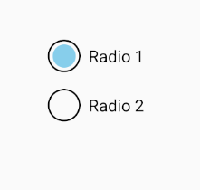

The output look like below is the output of last lesson and now we will continue later so what we learned in last lesson and what we will learn in this lesson what is the difference in it is that in last lesson we make Touchable Opacity a radio button but now we will name static Touchable Opacity we will take It dynamic Now suppose in an array there are 10 skills and in among 10 skills you can choose only one skills. SO we add some skills in the array like PHP, Nodejs etc and then we will loop over them in the map function and you can select any of them. So we mean the you don’t have to define individually inside loop your radio button will be there How you can select inside it and unselect inside it by the code it will also told by the Teacher.

1:26

SO don’t forget to visit previous lesson because style was discussed there. At first we make an array for skills and then we take a map function of js and will run loop on radio button so we can see many of radio button whatever skills we have and later we will update state on the basis of that skill and then you can do select and deselect radio button and at last Teacher will discuss some interview question

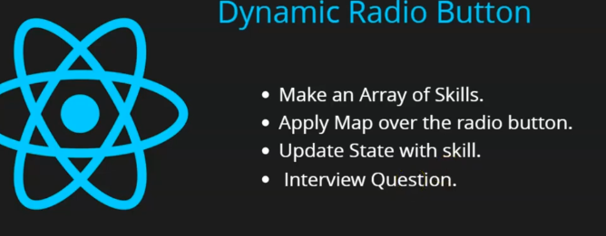

Now we remove the second radio button now our design code look like below

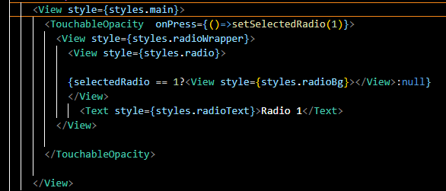

Now when you see your app then there is a single radio button and it is selected as the default value of selectedradio state is 1

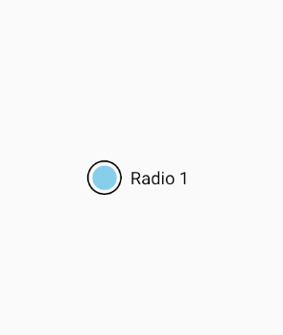

You can take a state but we are taking a const because we are not going to update the list and the things which we don’t want to update you can take its variable or constant if you have to update it with setState like we have done with buttons and there is UI dependency then you can take it state otherwise you can take variables like lets, const etc(who knows)

We make an array of name skills and we will take object as a member and each object representing a skill suppose if we take a parameter inside that is name with a value ‘Java’ and we take another property and name it as id with a value as 1. We will need id that’s why so we take an object inside which if you want you can add another property but you need at least two properties and now we added another object in the skills list with id = 2 and name PHP now similarly add another skill of id 3 and name of Node and then add another skill of id 4 and name is SQL Now our array look like below

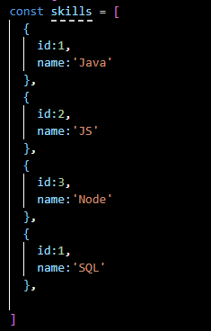

4:00

Now we run map function on the skills array. Then 4 radio buttons should be there and they should be properly selected so for that we just cut our only TouchableOpacity here and use map method on our skills array and we know map function take a callback function and inside that callback paste the Touchable opacity we did cut so now our design code look like below

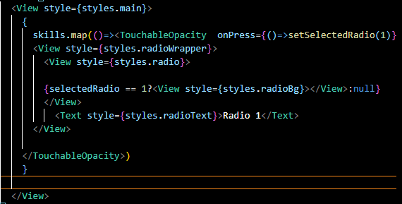

Now out output look like below

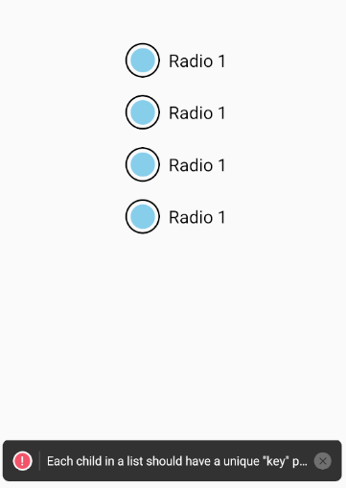

Now we have four radio buttons here but you can see there is error saying that each child in a list should have a unique key so for that in the callback of the map pass the perimeter that is item the item is for iterating every element of our array in our case these are objects containing different skills. The second parameter is index . you can make this index a key of the every element the array will produce. So now it we add key it look like below

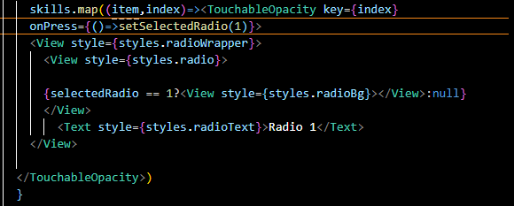

Now you will not see the error as shown below

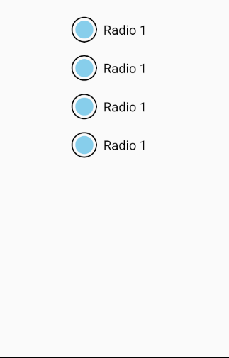

Now we make the label of the radio button dynamic by using item parameter that will access ach element of the array and we access name property of objects inside skulls array Now our code look like below

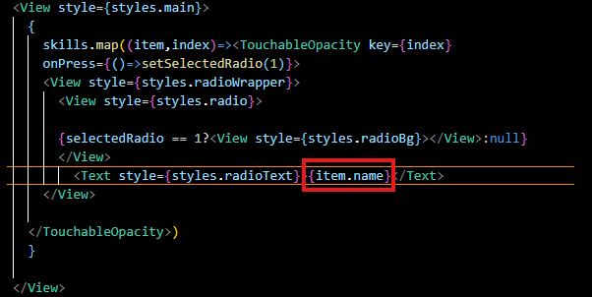

Now our output will look like below

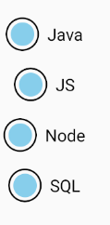

Now you can see all the radio button with their unique labels and all are selected as shown above

Now we also make our conditional in TouchableOpacity dynamic such that selectedRadio === item.id. if that is true then only it is seleceted otherwise not

Now our code look like below

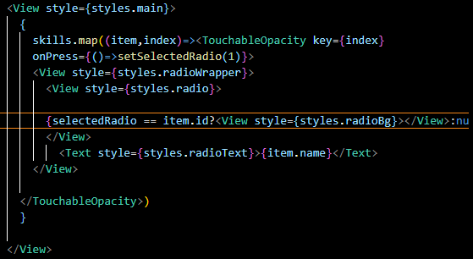

Now since selected radio default value is 1 so first radio button will be selected as shown below

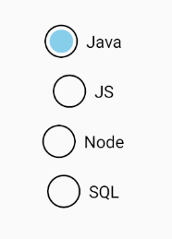

Now how we update the selected Radio by passing intex.id to the setSelectedRadio in onPress of untouchables as marked below

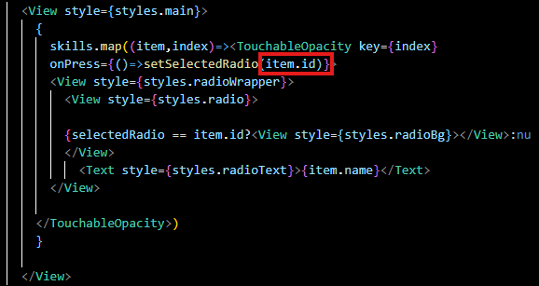

5:51

Now suppose we checked third radio button then selected radio id is 3 and it will again check to all the radio button item.id and to whom it matches that radio button will be selected

Now it will work as shown below



Now you can see above all are perfectly been selected. So by this way you can go dynamic now suppose you want to add one more item in the skill array. Rememeber that id should be unique otherwise you will face some problems so we add a skill of python as shown below in the skills array

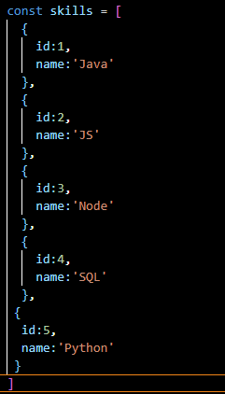

Now you can see there are five radio buttons in our output as shown below

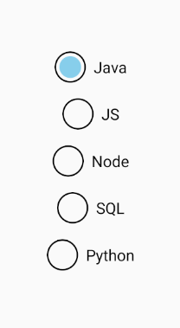

They are slightly not in line you can adjust it if you want with the help of css

And it is also a task given by the teacher how you will properly arrange it so that they will be in common line by justfied item or align (who knows). That’s all for this lesson. It was a small part but we learnt how to make dynamic radio button. In next lesson we will take one or two UI element that is UI component of React native and then we will move onto React navigation. six – seven lesson will come on it. We will learn it properly. See you in the next lesson.